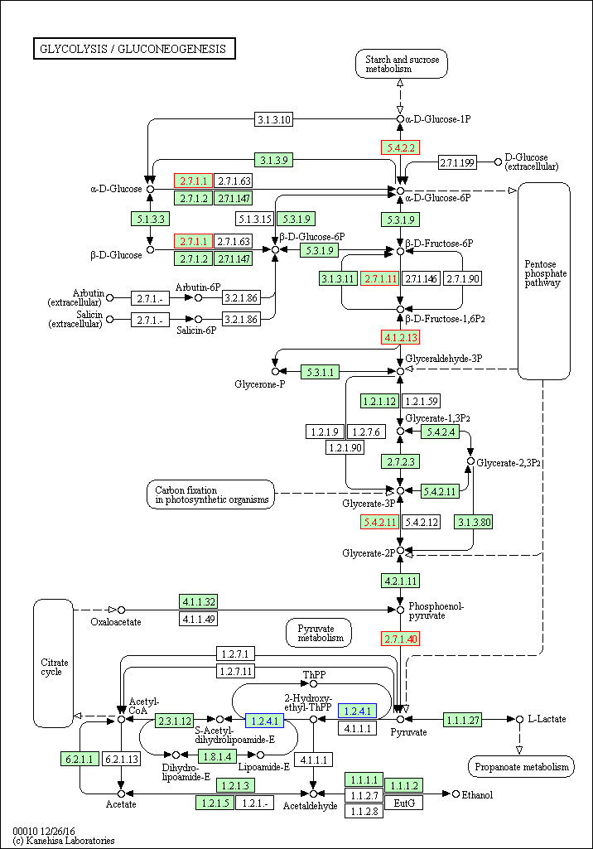

Fig.S1 Representative KEGG pathway for Glycolysis
Blue signifies down-regulated mRNA splicing associated proteins in aging HSPCs compare with young HSPCs; Red signifies up-regulated mRNA splicing associated proteins in aging HSPCs compare with young HSPCs.

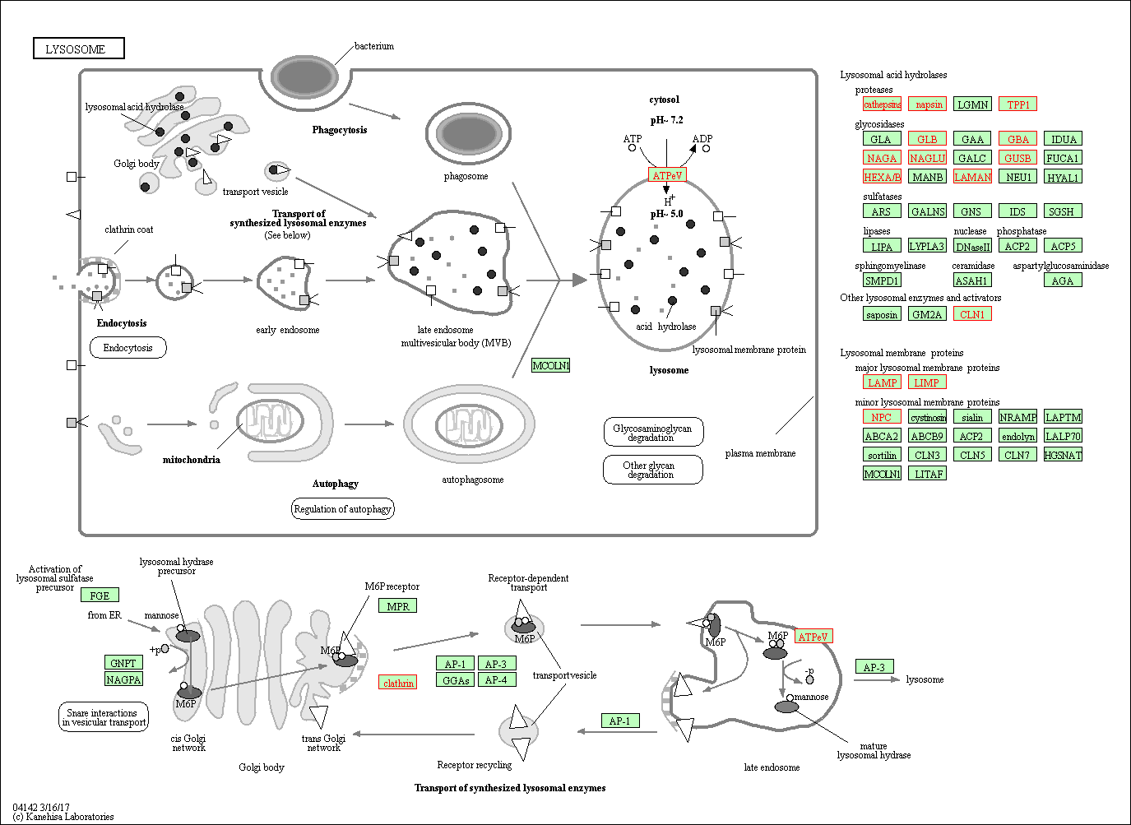

Fig.S2 Representative KEGG pathway for Lysosome
Red signifies up-regulated mRNA splicing associated proteins in aging HSPCs compare with young HSPCs.

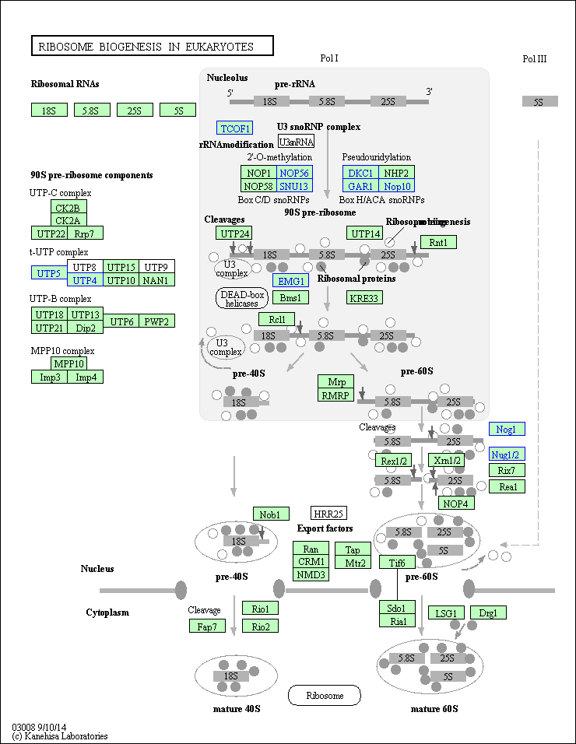
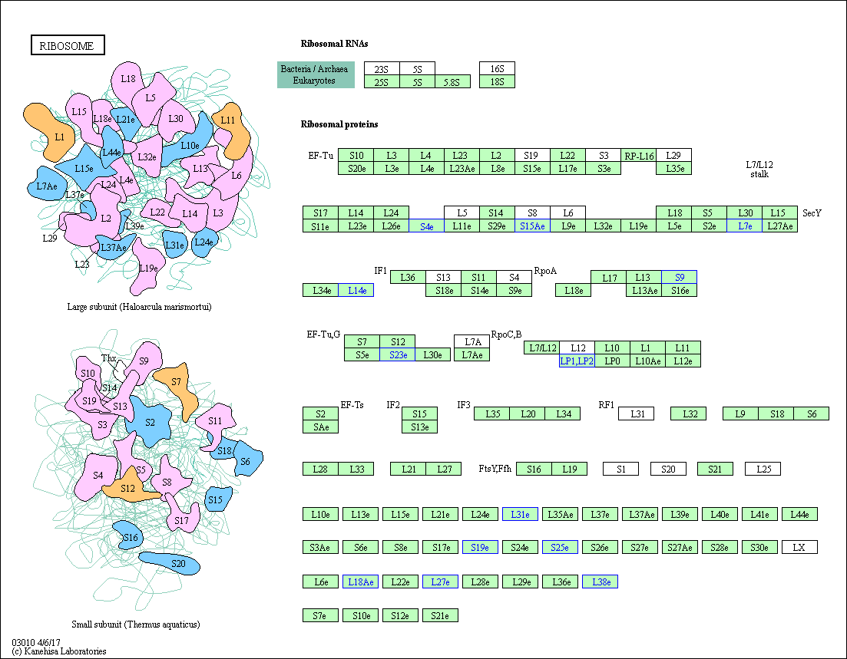

Fig.S3 Representative KEGG pathway for Ribosome
Blue signifies down-regulated mRNA splicing associated proteins in aging HSPCs compare with young HSPCs;

